TAYSIDE MACHINERY LTD
SCOTLAND
TELE: 0044 (0) 1382 200797 FAX: 0044 (0) 1382 202853
e-mail: sales@taysidemachinery.co.uk website: www.taysidemachinery.co.uk

Mitsui – Seiki HR6A Twin Pallet Horizontal Machining Centre
ST3558

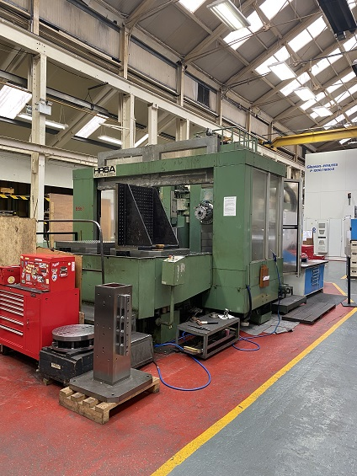

Mitsui – Seiki HR6A Twin Pallet Horizontal Machining Centre

Model: HR6A
Control: Fanuc 18i

Pallet Size: 1000 x 1000mm
4 Axis Machine

‘X’ Axis: 1300mm
‘Y’ Axis: 1000mm
‘Z’ Axis: 1000mm
Table Indexing 1 degree increments

Spindle Speeds: 4500 RPM
Spindle Taper: 50 ISO

Table Capacity: 3000 KGS
Tool Changer: 60 Station
Coolant and Swarf Conveyor

EX - MOD

